

SITE POLLUTION INCIDENT RESPONSE MANAGEMENT PLAN

Yates Australia

34 WYEE ROAD WYEE 2259

Emergency Response

**DuluxGroup Emergency Response Service**

**1800 220 770**

Contents

Document Control………………………………………………………………………………………...3

Document Control 3

Current Revision 4

Purpose 4

Introduction 4

Definition of a Pollution Incident 5

Notification of a Pollution Incident 5

Scope 5

Pollution Response Team Responsibilities 5

Pollution Incident Response Team Roles 6

Pollution Response Key Contacts 7

Neighbours Contacts 8

Potential Pollution Incidents 9

Dangerous & Combustible Goods Manifest 12

Site Map – Factory 13

Team Training 14

Plan Testing 14

Reference Documents 14

Legislation 14

Storage 14

## 

## ****Document Control****

|  |  |  |  |
| --- | --- | --- | --- |
| **Issue** | **Date** | **Revision Changes** | **By** |
| 13.0 | 14/02/2025 | Review of plan contents, update Ministry of Health contact details. | S&S Advisor |
| 12.0 | 16/02/2024 | Review of plan contents | S&S Advisor |
| 11.0 | 10/02/2023 | Review of plan contents | S&S Business Lead – Yates |
| 10.0 | 10/02/2022 | Review of plan contents | S&S Business Lead – Yates |
| 9.0 | 10/04/2021 | Review of plan contents and key contacts. | S&S Business Lead – Yates |
| 8.0 | 10/03/2020 | Update changes to DG Manifest, update logo. S&S Review. | S&S Business Lead – Yates |
| 7.1 | 01/02/2019 | S&S Review | S&S Business Lead – Yates |
| 6.1 | 09/03/2018 | S&S Review | S&S Advisor |
| 6.0 | 19/05/2017 | Review of plan contents and key contacts. Communicated plan to all key contacts | Site Manager and S&S Advisor |
| 5.1 | 15/07/2015 | Review plan to ensure key contacts are updated. Communicated plan to all key contacts. | S&S Manager |
| 4.1 | 26/02/2015 | Review plan against NSW EPA Environmental Guidelines: Preparation of pollution incident response management plant | S&S Advisor |
| 4.0 | 29/07/2014 | Review plan to ensure key contacts are updated. Communicated plan to all key contacts. | S&S Manager & Site Manager |
| 3.0 | 30/09/2013 | Reviewed and updated the plan to ensure current key contacts are listed and in response to a DuluxGroup legal review. | S&S Manager & Site Manager |
| 2.0 | 10/09/2012 | Plan updated to remove Neighbour contacts and DG volumes indicated on site map. | Site Manager & S&S Manager |
| 1.0 | 30/08/2012 | Draft plan developed. | ERT |

## ****Current Revision****

|  |  |  |  |  |
| --- | --- | --- | --- | --- |
| **Date Implemented** | **Version** | **Approval Position** | **Test / Schedule** | **Next Review** |
| 14/02/2025 | 13.0 | Operations Manager | 12 monthly | 14/02/2026 |

## ****Purpose****

The purpose of this plan is to outline the site procedure to be followed when responding to a pollution incident to minimise environmental and business impact and to ensure a pollution incident is managed in an effective manner.

This procedure has been developed to outline the actions required by site management in the event of a pollution incident.

A pollution response procedure is required as part of the site Environmental Protection License and can been made available to members of the public on the DuluxGroup company website or by written request to the site.

The procedure covers potential pollutant hazards and controls, and the sites incident response process should a pollution incident occur. Due to unpredictability of incidents and emergency situations it must be understood that some circumstances may arise that are not covered by this procedure but those identified in our site Emergency Management Risk Assessment have been included.

This plan does not replace or supersede the site Emergency Management Plan that may also be operational at the same time to manage other types of emergency situations.

Upon activation of the pollution response plan the site management team can request the assistance of the business Crisis Management Team.

## ****Introduction****

The DuluxGroup Wyee Site occupies 34 hectares at 34 Wyee Road, Wyee NSW 2259. The facility comprises of an administration building, manufacturing area, raw material manure shed, distribution storage, eight water dams, employee car park and surrounding garden grounds.

The site operations hours fluctuate seasonally operating between 6am – 6pm and 6am – 10pm Monday to Thursday and from 6am – 5pm on Fridays; also including Saturdays as required 6am- 2pm.

Residential homes border the sides of the property. The M1 motor way travels along the rear of the site.

## ****Definition of a Pollution Incident****

*A* ***pollution incident*** means an incident or set of circumstances during or as a consequence of which there is or is likely to be a leak, spill or other escape or deposit of a substance, as a result of which pollution has occurred, is occurring or is likely to occur. It includes an incident or set of circumstances in which a substance has been placed or disposed of on premises, but it does not include an incident or set of circumstances involving only the emission of any noise.

## ****Notification of a Pollution Incident****

A pollution incident is required to be notified if there is a risk of ‘material harm to the environment’, which is defined in section 147 of the POEO Act as:

1. harm to the environment is material if:
2. it involves actual or potential harm to the health or safety of human beings or to ecosystems that is not trivial, or
3. it results in actual or potential loss or property damage of an amount, or amounts in aggregate, exceeding $10,000 (or such other amount as is prescribed by the regulations), and
4. loss includes the reasonable costs and expenses that would be incurred in taking all reasonable and practicable measures to prevent, mitigate or make good harm to the environment.

Yates Wyee is now required to report pollution incidents immediately to the EPA, NSW Health, Fire and Rescue NSW, Work Cover NSW and the local council. ***‘Immediately’*** has its ordinary dictionary meaning of promptly and without delay.

## ****Scope****

This PIRMP must be followed by employees, contractors and visitors to Yates Wyee to assist in the early response and reporting of a pollution incident.

## ****Pollution Response Team Responsibilities****

The Pollution Response Team is responsible for accessing the overall severity of the incident and controlling of any pollution incident until the incident is under control and an initial investigation has been completed.

The Team’s responsibilities include:

* Activating the initial incident response to ensure effective control of the situation.
* Activating the site emergency evacuation procedures to ensure the health and safety of all workers.
* Prevent unauthorised access to the incident area.
* Notifying emergency services and appropriate regulatory authorities of the incident
* Notify direct neighbours / members of the community about the incident.
* Respond to issues as they arise during the incident.
* Obtaining and collating information from internal and external sources.
* Ensuring that appropriate personnel are kept informed of the incident.
* Managing internal and external communications

## ****Pollution Incident Response Team Roles****

|  |  |
| --- | --- |
| **Roles**  **Contact ERS (1800 220 770) for connection with any roles listed below** | **Responsibilities** |
| INCIDENT CONTROLLERS  Site Manager | * Assess the incident situation and activate the site Emergency Response Team if required * Activate the site emergency evacuation procedure. * Manage the site evacuation procedure. * Liase with emergency services and regulatory authorities upon arrival. * Notify appropriate regulatory authorities of the pollution incident. |
| EQUIPMENT TECHNICIAN  Maintenance Production Supervisor | * Assess the incident scene and manage the clean-up and control process. * During emergency evacuation prevent unauthorised access to the site * Upon request contact emergency services. |
| COMMUNITY LIASON  S&S Manager | * Notify direct neighbours and members of the community about the incident. |
| INCIDENT NOTIFYER  S&S Manager | * Assist with Notification of appropriate regulatory authorities of the pollution incident. * Obtain and collate information from internal and external services. * Maintain documentation of evidence provided to authorities. |
| INTERNAL COMMUNICATIONS MANAGER  Operations Manager – Yates | * Manage internal communications within DuluxGroup |
| To maintain employee confidentiality, the Pollution Response Team contact details are held with the DuluxGroup Emergency Response Service. Contact details are updated every 6 months or upon change of role. To report an incident or contact the team by calling 1800 033 111 | |

## ****Pollution Response Key Contacts****

Any pollution incident satisfying the material harm threshold must be immediately reported to relevant statutory authorities by either the Operations Manager, S&S Manager or S&S Advisor.

In cases where material harm level cannot be immediately assessed, or insufficient information is available on the severity of the incident, the general advice is to notify the Relevant Authorities and discuss that the situation could not be fully assessed. The incident notification should be limited to facts known and records of the notification must be documented. The following facts should be provided at the time of notification: Location & time, Type of incident (e.g., fire, spill, escape, explosion) and Initial response taken

**Regulatory Contacts**

|  |  |  |
| --- | --- | --- |
| **Type** | **Contact Details** | **Role Required to Contact** |
| Emergency Services (NSW Fire & Rescue) | 000 | Operations Manager  Safety & Sustainability Manager  Safety & Sustainability Advisor |
| Department of Environment & Heritage  (NSW EPA) | 02 9695 2777,  Environment Line: 131 555 |
| Ministry of Health (Pollution Incident) | Gosford Public Health Unit  (Central Coast LHD)  PO Box 361, Gosford, 2250  Phone: (02) 4320 9730  Fax: (02) 4320 9746 (secure line)  After hours  Phone: (02) 4924 6477  (John Hunter Hospital)  - ask for Public Health Officer on call |
| Work safe NSW | 13 10 50 |
| Poisons Information | 13 11 26 |

**External Services Contacts**

|  |  |  |
| --- | --- | --- |
| **Type** | **Contact Details** | **Role Required to Contact** |
| Electricity Supplier – Origin  Provider Ausgrid | 13 13 65 | Site Manager / Engineering Manager |
| Gas Supplier – Energy Australia Origin  Provider Jimena | 13 19 09 | Site Manager / Engineering Manager |
| Water Suppler – Hunter Water Corp | 1300 657 657 | Site Manager / Engineering Manager |

## ****Neighbours Contacts****

|  |  |  |  |
| --- | --- | --- | --- |
| **Type** | **Location** | **Contact Details** | **Role Required to Contact** |
| Residential Rural Property | Wyee Road, Wyee NSW 2259 | Contact details can be found in site Emergency Plan | COMMUNITY LIASON |
| Residential Rural Property | 15 Schofield Road Wyee NSW 2259 | Contact details can be found in site Emergency Plan | COMMUNITY LIASON |
| Residential Rural Property | 42 Wyee Road Wyee NSW 2259 | Contact details can be found in site Emergency Plan | COMMUNITY LIASON |
| Residential Rural Property | 40 Wyee Road Wyee NSW 2259 | Contact details can be found in site Emergency Plan | COMMUNITY LIASON |

## ****Potential Pollution Incidents****

| **Incident Type** | **Possible Case / Hazards** | **Incident Response** | **Site Controls** | **Likelihood** |
| --- | --- | --- | --- | --- |
| Pollution from fire | * Smoke to air and danger to surrounding areas. * Dangerous goods spill * Ignition source in hazardous area * Equipment electrical failure | Minor Scenario response (smolder/spot fire)   * 1. Control Fire/ smolder. * 2. Notify Site Management * 3. Report though normal incident channels   Major Scenario response (Factory Fire/Explosion)   * Activate the nearest emergency alarm * Contact site manager to notify emergency services * Community Communications Representative to inform neighbours of incident. * Attack fire if safe to do so * Shut down equipment * Evacuate to safe assembly area * Remain in assembly area until the all clear is given by emergency services and Chief Fire Warden. * Clean the area and remove damaged equipment. * Hold a debrief session to document site response and determine improvement initiatives. | * Extinguishers * Hose Reels * Sprinkler System * Alarm System * Fire Team * First Attack Training | MEDIUM |
| Diesel spill (5000 L Maximum) or Canola Oil Spill (10000 L Maximum) * | * Contamination of waterways * Forklift contact with tank * Dropping IBC Container * Tank Damage * Leak | Minor Scenario response (Contained Spill)   * Attack the spill to prevent spreading, entering storm water drains/waterways. * Notify Site Management * Barricade spill area to prevent access * Use absorbent material to clean the spill * Dispose of spill cleanup material appropriately * Report though normal incident channels   Major Scenario response (Contamination of ground/waterways)   * Attack the spill to prevent further spreading or entering storm water drains/waterways. * Notify the Site Manager of any loss of containment * Use absorbent material to clean the spill * Barricade spill area to prevent access * Dispose of spill cleanup material appropriately * Ensure spill is contained on site and test first flush water before release. * Inform regulatory authority if spill not contained to site. * Hold a debrief session to document site response and determine improvement initiatives. | * Trained and competent forklift drivers with loads secured to tynes. * Storm water drain shut off valves * Bunded areas * Spill kits * Spills response training * Extraction & Dust collector system clean-out and maintenance procedures * Manifest listing DG’s stored on site | LOW |
| Distribution | * Truck collision causing spill * Forklift loading / unloading truck causing spill | * Contact freight company * Activate emergency response clean up * Barricade spill | * Chain of Responsibility Audits * Load Restraint * EPG’ | MEDIUM |
| Overflow of wastewater treatment dam | * Contamination of waterways or land * Heavy Rainfall and pump failure. | Minor Scenario response (Overflow contained onsite)   * Notify Site Management. * Pump up to irrigation dam. * Report though normal incident channels.   Major Scenario response (Overflow not contained onsite)   * Notify Site Management. * Attempt to Pump up to irrigation dam. * Shut down site. * Site Manager and S&S Manager to inform/Liaise with regulatory authority as required * Hold a debrief session to document site response and determine improvement initiatives. | * Water treatment system to treat nutrient rich wastewater (Site Dams systems) | MEDIUM |
| Release of Odour | * Contamination to air * Failure of Odour control system | Minor Scenario response (Single Odour Complaint)   * Inform site management of any complaint. * Raise as a community complaint within internal. * Site Manager and S&S Manager to inform regulatory authority as required. * Start investigation using site template, collate information on weather, biofilter and other factors which may be involved.   Major Scenario response (Multiple Odour Complaints)   * Inform site management of any complaint. * Site shutdown pending investigation of cause. * Raise as a community complaint within internal. * Site Manager and S&S Manager to inform/Liaise with regulatory authority as required. * Hold a debrief session to document site response and determine improvement initiatives. | * Odour control system * Biofilter | MEDIUM |
| Release of Dust | * Contamination to air * Dust Collector failure | Minor Scenario response (Overflow contained onsite)   * Control / Clean up dust release. * Notify Site Management. * Report though normal incident channels.   Major Scenario response (Overflow not contained onsite)   * Activate the nearest emergency alarm. * Contact site manager to notify emergency services. * Community Communications Representative to inform neighbours of incident. * Shut down equipment. * Evacuate to safe assembly area. * Remain in assembly area until all clear is given by emergency services and Chief Fire Warden. * Site Manager and S&S Manager to inform/Liaise with regulatory authority as required. * Hold a debrief session to document site response and determine improvement initiatives. | * Dust collectors with fail safe shutdown and maintenance | LOW |

## ****Dangerous & Combustible Goods Manifest****

|  |  |  |  |  |  |  |  |
| --- | --- | --- | --- | --- | --- | --- | --- |
| **Site Storage Area** | **Storage ID** | **Proper Shipping Name** | **Class / Division** | **Type** | **Design Capacity** | **Max Store** | **Typical Quantity** |
| Fertz Bay – External | DG T2 | Diesel | C1 | Tank | Above ground storage tank | 5,000L | 3,500L |
| Processing Plant – Internal | DG T1 | Canola oil | C2 | Tank | Above ground storage tank | 5,000L | 3,500L |
| Argon Gas | Workshop | Argon Gas | 2.2 | Gas cylinders | Gas cylinders | 20,000L | 5000L |
| Acetylene Gas | Workshop | Acetylene Dissolved | 2.1 | Gas cylinders | Gas cylinders | 3000L | 1000L |
| LPG Gas | Workshop | Petroleum Gases Liquefied | 2.1 | Gas cylinders | Gas cylinders | 15000L | 5000L |
| Manganese Sulphate | Warehouse | Manganese sulphate, monohydrate | 9 | 25kg bags | Bags on pallets | 1000kg | 750kg |

## ****Site Map – Factory****

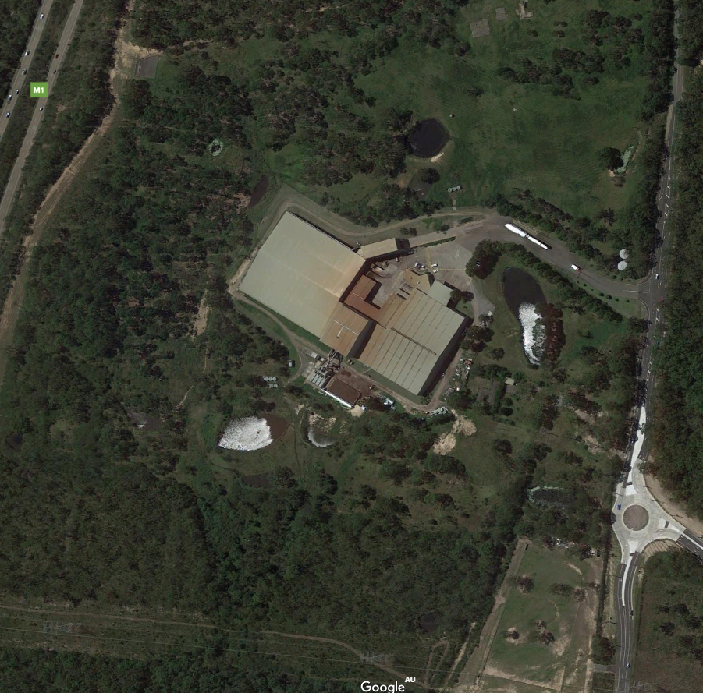 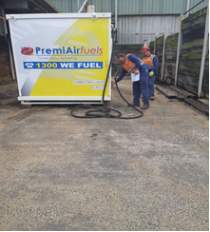

Workshop

Warehouse

Office

Fertilizer Bay

Packing lines

Biofilter

Raw Manure Shed

Canola Oil

5,000 L Diesel

Process Plant

## ****Team Training****

The pollution response team has been trained in the pollution incident response plan and is made aware of any updates to the plan. The plan will be reviewed as part of the Site Emergency Procedure Review.

The Emergency Team has been trained in spill response procedures and are aware of the hazards on site. As part of the Emergency Response Plan regular evacuation tests are conducted.

## ****Plan Testing****

The plan will be tested as part of the Site Emergency Response Procedure. Specific scenarios will be developed to conduct a trial emergency response.

The plan will be reviewed yearly as part of the Site Emergency Response Procedure Review.

## ****Reference Documents****

DuluxGroup RSK-003: Emergency and Crisis Plans

Yates Wyee Emergency Management Plan

NSW Environment Protection Authority, Environmental guidelines: Preparation of pollution incident response management plans 2012

## ****Legislation****

NSW Environment Protection Authority, Environmental guidelines: Preparation of pollution incident response management plans 2012

Protection of the Environment Operations Act 1997

Protection of the Environment Operations (General) Regulation 2009

# 

## ****Storage****

|  |  |
| --- | --- |
| **Copy Type** | **Location** |
| Hard copy | Yates Wyee Manufacturing Administration Office  Yates Wyee Manifest Box |
| Electronic | Public Access Online on Yates Website [Corporate | Yates Australia](https://www.yates.com.au/about-us/corporate/)  Site Electronic Plant Dossier |