

SITE POLLUTION INCIDENT RESPONSE MANAGEMENT PLAN

Yates Australia

9 Coventry Place Mt Druitt NSW

Emergency Response

**DuluxGroup Emergency Response Service**

**1800 033 111**

Contents

Document Control 3

Current Revision 3

Purpose 4

Introduction 4

Definition of a Pollution Incident 5

Notification of a Pollution Incident 5

Scope 5

Pollution Response Team Responsibilities 5

Pollution Incident Response Team Roles 6

Pollution Response Key Contacts 7

Regulatory Contacts 7

Neighbour Contacts 8

Potential Pollution Incidents 10

List of Polluting Substances 11

Site Map - Factory 12

Site Map - Warehouse 14

Team Training 15

Plan Testing 15

Reference Documents 15

Legislation 15

Storage 16

**Document Control**

|  |  |  |  |
| --- | --- | --- | --- |
| **Issue** | **Date** | **Revision Changes** | **Revised by title** |
| 2.10 | 28/08/2024 | S&S Review | S&S Advisor |
| 2.9 | 20/10/2023 | Update site details, Maps and Regulatory Contacts | S&S Advisor |
| 2.8 | 26/06/2023 | Update DG Manifest & Site Map | S&S Advisor |
| 2.7 | 10/01/2022 | Update new contacts | S&S Business Lead |
| 2.6 | 20/04/2021 | Update contacts | S&S Business Lead |
| 2.5 | 05/05/2020 | DG Update and S&S Review | S&S Advisor |
| 2.4 | 01/02/2019 | S&S Review | S&S Business Lead |
| 2.3 | 09/03/2018 | S&S Review | S&S Advisor |
| 2.2 | 24/07/2017 | Plan reviewed with site manager | Factory Manager  Warehouse Manager |
| 2.1 | 16/04/2015 | Review plan against NSW EPA Environmental Guidelines: Preparation of pollution incident response management plant. Inclusion of pollution ‘definition’ and ‘notification’. | S&S Advisor |
| 2.0 | 25/07/2014 | Plan reviewed with site manager | S&S Business Lead |
| 1.0 | 24/08/2014 | Draft plan developed. | Warehouse Manager |

# 

# Current Revision

|  |  |  |  |  |
| --- | --- | --- | --- | --- |
| **Date Implemented** | **Version** | **Approval Position** | **Test / Schedule** | **Next Review** |
| 28/08/2024 | 2.10 | S&S Business Lead | 12 monthly | August 2025 |

# 

# Purpose

The purpose of this plan is to outline the site procedure to be followed when responding to a pollution incident to minimise environmental and business impact and to ensure a pollution incident is managed in an effective manner.

This procedure has been developed to outline the actions required by site management in the event of a pollution incident. A pollution response procedure is required as part of the site Environmental Protection Licence and can been made available to members of the public on the DuluxGroup company website or by written request to the site.

The procedure covers potential pollutant hazards and controls, and the sites incident response process should a pollution incident occur. Due to unpredictability of incidents and emergency situations it must be understood that some circumstances may arise that are not covered by this procedure but those identified in our site Emergency Management Risk Assessment have been included.

This plan does not replace or supersede the site Emergency Management Plan that may also be operational at the same time to manage other types of emergency situations. Upon activation of the pollution response plan the site management team can request the assistance of the business Crisis Management Team.

# Introduction

The DuluxGroup Mt Druitt Site occupies 4.7 hectares at 9 Coventry Place, NSW. The facility comprises of an administration building, manufacturing area, distribution center and employee car park. The site usually operates over two shifts from 6am – 11pm, Monday to Friday but can operate a night shift and on Saturdays if volume permit.

The Western Rail Line and residential homes border the rear of the site. Other industrial facilities such as manufacturing and warehousing facilities border the front of the sides of the premises. The boundary to the West has a power line easement.

# Definition of a Pollution Incident

*A* ***pollution incident*** means an incident or set of circumstances during or as a consequence of which there is or is likely to be a leak, spill or other escape or deposit of a substance, as a result of which pollution has occurred, is occurring or is likely to occur. It includes an incident or set of circumstances in which a substance has been placed or disposed of on premises, but it does not include an incident or set of circumstances involving only the emission of any noise.

# Notification of a Pollution Incident

A pollution incident is required to be notified if there is a risk of ‘material harm to the environment’, which is defined in section 147 of the POEO Act as:

1. harm to the environment is material if:
2. it involves actual or potential harm to the health or safety of human beings or to ecosystems that is not trivial, or
3. it results in actual or potential loss or property damage of an amount, or amounts in aggregate, exceeding $10,000 (or such other amount as is prescribed by the regulations), and
4. loss includes the reasonable costs and expenses that would be incurred in taking all reasonable and practicable measures to prevent, mitigate or make good harm to the environment.

Yates Mt Druitt is now required to report pollution incidents immediately to the EPA, NSW Health, Fire and Rescue NSW, Workcover NSW and the local council. ***‘Immediately’*** has its ordinary dictionary meaning of promptly and without delay.

# Scope

This PIRMP must be followed by employees, contractors and visitors to Yates Mt Druitt in order to assist in the early response and reporting of a pollution incident.

# Pollution Response Team Responsibilities

The Pollution Incident Response Team is responsible for the overall conduct and control of any pollution incident until such time as the incident is under control and an initial investigation has been completed. Once the “All clear” is given by emergency services and/or regulatory authorities the Pollution Response Team transfers responsibility for normal operation back to the Operations Manager.

The Team’s responsibilities include:

* Activating the initial incident response to ensure effective control of the situation.
* Activating the site emergency evacuation procedures to ensure the health and safety of all workers and to prevent unauthorised access to the incident area.
* Notifying emergency services and appropriate regulatory authorities of the incident
* Notify direct neighbors / members of the community about the incident.
* Respond to issues as they arise during the incident.
* Obtaining and collating information from internal and external sources.
* Ensuring that appropriate personnel are kept informed of the incident.
* Managing internal and external communications.

## Pollution Incident Response Team Roles

|  |  |
| --- | --- |
| **Roles**  **Contact ERS (1800 033 111) for connection with any roles listed below** | **Responsibilities** |
| INCIDENT CONTROLLERS  Factory Manager  Warehouse Manager | * Contact emergency services. * Assess the incident situation and activate the site Emergency Response Team if required. * Prevent further harm by controlling the incident scene, if safe to do so. * Activate the site emergency evacuation procedure, if required. * Manage the site evacuation procedure. * Liaise with emergency services and regulatory authorities. * During emergency evacuation prevent unauthorised access to the site. |
| EQUIPMENT TECHNICIAN  Maintenance & Reliability Leader | * Assess the incident scene and co-ordinate any equipment repairs and maintenance. |
| COMMUNITY LIASON  Production Manager | * Upon request from the Operations Manager or S&S Manager the production manager will notify direct neighbors and members of the community about the incident. * Assess the incident scene and manage the clean-up and control process. |
| INCIDENT NOTIFYER  S&S Business Lead  Safety & Sustainability Advisor | * Immediately (e.g., promptly and without delay) notify appropriate regulatory authorities of the pollution incident or make sure that the incident has been notified. * Obtain and collate information from internal and external services |
| INTERNAL COMMUNICATIONS MANAGER  Head of Supply Chain – Yates | * Manage internal communications within DuluxGroup |
| To maintain employee confidentiality, the Pollution Response Team contact details are held with the DuluxGroup Emergency Response Service. Contact details are updated every 6 months or upon change of role. To report an incident or contact the team by calling 1800 033 111 | |

# 

# Pollution Response Key Contacts

Any pollution incident satisfying the material harm threshold must be immediately reported to relevant statutory authorities by either the Operations Manager, S&S Manager or S&S Advisor.

In cases where material harm level cannot be immediately assessed or insufficient information is available on the severity of the incident, the general advice is to notify the Relevant Authorities and discuss that the situation could not be fully assessed.

The incident notification should be limited to facts known and records of the notification must be documented. The following facts should be provided at the time of notification: Location & time, Type of incident (e.g., fire, spill, escape, explosion) and Initial response taken.

## Regulatory Contacts

|  |  |  |
| --- | --- | --- |
| **Type** | **Contact Details** | **Role Required to Contact** |
| Emergency Services (NSW Fire & Rescue) | 000 | Safety & Sustainability Lead  Site Manager |
| Environmental Protection Authority | 131 555 |
| Ministry of Health | 02 9391 9000 |
| Safe Work NSW | 13 10 50 |
| Blacktown City Council | 02 5300 6000 |
| Poisons Information | 13 11 26 |
| Transport NSW (Trains) | 131 700 | Site Manager |

**External Services Contacts**

|  |  |  |
| --- | --- | --- |
| **Type** | **Contact Details** | **Role Required to Contact** |
| Electricity Supplier – Endeavour Energy | 131 003 | Site Manager |
| Water Authority | Sydney Water – 13 20 90 | Site Manager |
| Security Monitoring Service | 132 766 | Site Manager |

## Neighbor Contacts

Neighbor contact details can be provided upon request.

Role required to contact: Production Manager

| **Type** | **Location** |
| --- | --- |
| Warehouse & Depot Facility | 5 Coventry Place |
| Depot Facility | 6 Coventry Place |
| Warehouse Facility | 7 Coventry Place |
| Warehouse Facility | 8 Coventry Place |
| Warehouse Facility | 10 Coventry Place |
| Warehouse Facility | 112 Kurrajong Avenue |
| Warehouse Facility | 114 Kurrajong Avenue |
| Factory & Warehouse Facility | 118 Kurrajong Avenue |
| Factory & Warehouse Facility | 111 Kurrajong Avenue |
| Industrial Estate – Small Units | 99 Kurrajong Avenue |
| Depot Facility | 97 Kurrajong Avenue |
| Industrial Estate – Small Units | 101 Kurrajong Avenue |
| Industrial Estate – Small Units | 103 Kurrajong Avenue |
| Industrial Estate – Small Units | 105 Kurrajong Avenue |
| Warehouse facility | 109 Kurrajong Avenue |
| Factory & Warehouse Facility | 124 Kurrajong Avenue |
| Warehouse Facility | 126 Kurrajong Avenue |

# Potential Pollution Incidents

|  |  |  |  |  |
| --- | --- | --- | --- | --- |
| **Incident Type** | **Possible Case / Hazards** | **Incident Response** | **Site Controls** | **Likelihood** |
| Fire | * Ignition source in hazardous area * Dangerous goods spill * Equipment electrical failure | * Activate the nearest emergency alarm. * Contact factory manager to notify emergency services. * Control and Extinguish fire if safe to do so. * Shut down equipment. * Evacuate to safe assembly area. * Remain in assembly area until the “All clear” is given by emergency services and Chief Fire Warden. * Clean the area and remove damaged equipment. * Hold a debrief session to document site response and determine improvement initiatives. | * Extinguishers * Hose Reels * Sprinkler System * Alarm System * Fire Team * First Attack Training | MEDIUM |
| Spill  Chemical Liquids  Dust Propagation | * Forklift contact with drum * Dropping of drum, pot and other liquid & dust containers * Pipework leak * Silo damage / leak * Racking collapse Raw Material Storage Area * Dust collector release * Bund pit/overflow | * Activate the nearest emergency alarm. * Contact emergency services if required to assist with spill clean-up. * Activate site emergency evacuation procedures if necessary – obtain a copy of the Safety Data Sheet (SDS) for use by emergency services. * Review the spill situation and control the source to prevent spreading, entering storm water drains. * Barricade spill area to prevent exposure to vapors. * Ensure spill is contained on site, close drain valves and test first flush water. * Use absorbent material to clean the spill. * Dispose of spill cleanup material appropriately * Hold a debrief session to document site response and determine improvement initiatives. * Conduct environmental monitoring / review of any spill areas. | * Trained and competent forklift drivers with loads secured to tynes. * Storm water drain shut off valves. * Bunded areas * Spill kits * Spills response training * Extraction & Dust collector system clean-out and maintenance procedures * Manifest listing DGs stored on site | LOW |
| Distribution | * Truck collision causing spill. * Forklift loading / unloading truck causing spill | * Contact freight company. * Activate emergency response clean up. * Barricade spill | * Chain of Responsibility Audits * Load Restraint * EPG’s | MEDIUM |

# List of Polluting Substances

**\*** The site manifest lists the Dangerous Goods types and quantities stored onsite but the below gives a summary and indicates where stored onsite.

|  |  |  |  |  |  |  |  |
| --- | --- | --- | --- | --- | --- | --- | --- |
| **Tank ID No.** | **Dangerous Goods** | | | | **Tank** | | |
|  | **Name** | **Class / Type** | **UN No.** | **PG** | **Type** | **Capacity** | **Diameter** |
| DL1 | propane | 2.1 | 1978 | - | a/g | 1260 L |  |
| DL2 | propane | 2.1 | 1978 | - | A/G | 1260 L |  |
| DL2 | acetylene | 2.1 | 1001 | - | n/a | 300 l |  |
| DL2 | Argon, Compressed | 2.2 | 1006 | - | n/a | 300 l |  |
| DL2 | Argoshield, Compressed | 2.2 | 1956 | - | N/A | 300L |  |
| DL2 | Petroleum Gases, Liquified | 2.1 | 1075 | - | n/a | 300 l |  |
| DL3 | Oxygen, Compressed | 2.2 | 1072 | - | n/a | 300 l |  |

|  |  |  |  |  |  |
| --- | --- | --- | --- | --- | --- |
| **Area** | **Dangerous Goods** | | | | **Largest Quantity** |
|  | **Name** | **Class** | **UN No.** | **PG** |  |
| DL4 | D-Limonene | 3 | 2319 | III | 3200L |
| DL4 | Eucalyptus Oil | 3 | 1993 | III | 800L |
| DL5 | Pesticide, Solid, Toxic, N.O.S. (Rodenone Dust) | 6.1 | 2588 | III | 2000 |
| DL5 | Coumarin Derivative Pesticide, Liquid, Toxic (53691- Brodifacoum L-Blue) | 6.1 | 3026 | III | 600 |
| DL5 | Carbamate Pesticide, Solid, Toxic (Methiocarb) | 6.1 | 2757 | II | 1200 |
| DL5 | Bromoxynil Phenol, Solid, Toxic (R0059) | 6.1 | 2811 | III | 250 |
| DL5 | Phosphoric Acid, Solution | 8 | 1805 | III | 4000L |
| DL5 | Phosphorus Acid | 8 | 2834 | III | 4000Kg |
| DL5 | Hydrochloric Acid | 8 | 1789 | II | 1300L |
| DL5 | WARFARIN (22249) | 6.1 | 3027 | II | 300Kg |
| DL5 | BRODIFACOUM 0.5% (53056) | 6.1 | 3027 | II | 1500Kg |
| DL5 | CORROSIVE LIQUID, ACIDIC, ORGANIC, N.O.S.  (2,2-Di-Bromo-3-Nitrilo-Propionamide) | 8 | 3265 | III | 50L |
| DL6 | Sulphur | 4.1 | 1350 | III | 7500Kg |
| DL6 | Metaldehyde | 4.1 | 1332 | III | 5000kg |
| DL7 | Matrilox Perargonic Acid | C2 | - | N/A | 21000L |
| DL7 | Canola Oil | C2 | - | N/A | 45000L |
| DL7 | Oilwin (Methyl Salicylate) | C1 | - | N/A | 1000L |
| DL8 | Potassium Nitrate | 5.1 | 1486 | III | 5000kg |
| DL8 | Calcium Nitrate | 5.1 | 1454 | III | 1000kg |
| DL8 | Potassium Hydroxide | 8 | 1814 | II | 4000Kg |
| DL8 | Caustic Alkali Liquid N.O.S. (PROXEL GXL) | 8 | 1719 | II | 1000L |
| DL8 | Potassium Hydroxide Solution | 8 | 1814 | II | 6000L |
| DL8 | Sodium Percarbonate | 5.1 | 3378 | II | 1000kg |
| DL9 | Ammonium Nitrate Based Fertiliser | 9 | - | III | 8000kg |
| DL9 | Environmentally Hazardous Substance, Solid | 9 | 3077 | III | 5000kg |
| DL9 | Environmentally Hazardous Substance, Liquid, N.O.S. (Permethrin) | 9 | 3082 | III | 20000L |
| DL10 | Ethanol (Ethyl Alcohol) | 3 | 1170 | II | 250L |
| DL10 | Flammable Liquid, N.O.S. | 3 | 1993 | II | 250L |
| DL10 | Terpene Hydrocarbons, N.O.S. - (Contains d-Limonene) | 3 | 2319 | III | 250L |
| DL10 | Maintenance Oil / Grease (Bunded Pallet) | C1 | - | N/A | 2000L |
| DL11 | Aerosols | 2 | 1950 | - | 40000L |
| DL11 | Ethanol (Ethyl Alcohol) | 3 | 1170 | II | 15000L |
| DL11 | Corrosive Liquid N.O.S (CONTAINS BENZALKONIUM CHLORIDE) | 8 | 1760 | II | 5000L |
| DL11 | Ammonium Nitrate Based Fertiliser | 9 | - | III | 50000kg |
| DL11 | Environmentally Hazardous Substance, Solid | 9 | 3077 | III | 40000kg |
| DL11 | Environmentally Hazardous Substance, Liquid, N.O.S. (Permethrin) | 9 | 3082 | III | 270000L |

# Site Map – Factory

**Site Storage Locations**

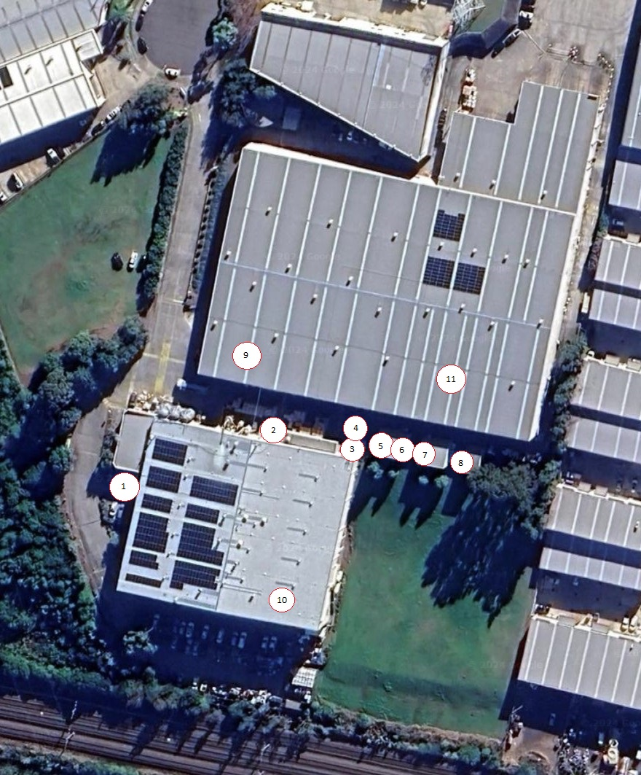

# Team Training

The pollution response team has been trained in the pollution incident response plan and is made aware of any updates to the plan. The plan will be reviewed as part of the Site Emergency Procedure Review.

The Emergency Team has been trained in spill response procedures and are aware of the hazards on site. As part of the Emergency Response Plan regular evacuation tests are conducted.

# Plan Testing

The plan will be tested as part of the Site Emergency Response Procedure. Specific scenarios will be developed to conduct a trial emergency response.

The plan will be reviewed yearly as part of the Site Emergency Response Procedure Review.

# Reference Documents

DuluxGroup RSK-003: Emergency and Crisis Plans

Yates Mt Druitt Emergency Management Plan v6.10

NSW Environment Protection Authority, Environmental guidelines: Preparation of pollution incident response management plans 2012

# Legislation

Protection of the Environment Operations Act 1997

Protection of the Environment Operations (General) Regulation 2009

# Storage

|  |  |
| --- | --- |
| **Copy Type** | **Location** |
| Hard copy | Yates Mt Druitt Manufacturing Administration Office |
| Electronic | Public Access Online on Yates Website  Site E  Electronic Plant Dossier |